|  |
| --- |
| Alexandre Bescond  Master student  alexabes@student.matnat.uio.no  Etienne Bernoux  Master student  etiennb@student.matnat.uio.no |
|  |

|  |
| --- |
| **Assigmnent 2**  **INF5040 - Open distributed processing**  Autumn semester 2017 |

Table of contents

Introduction 2

1. Spreading the word 2

2. Tracing non-projectivity 2

3. Using parsers 3

3.1 Training 3

3.2 Evaluation 3

4. Parsing one language with another 6

# Ephemeral vs Persistent (Regular) znodes

## Create a znode

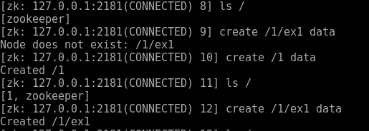

## Create another persistent node



## Create node ephemeral



## List the children



## Now quit the client by



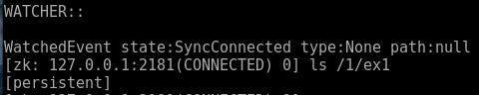

The ephemeral is gone :’( , the session who create the node has gone so the node as disappear too. A ephemeral node (create cy -e) is dependent on a session. By quitting the session this node disappear.

## Create a new ephemeral znode

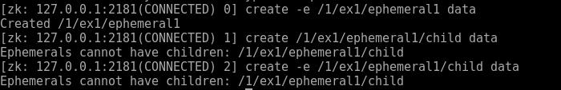

Because of if ephemeral behavior, this node cannot have children.

# Sequential suffix

## Create the znode for this exercise



## Create a few znodes with SEQUENTIAL suffix

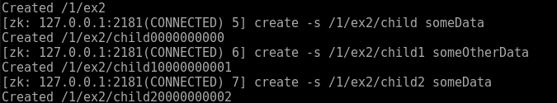

#### Q1



The sequential mode add an increasing couter at the end of the name. This counter value is unique for this parentZNode. The counter have a 10 digits formats starting at 0. With a 0 padding.

#### Q2

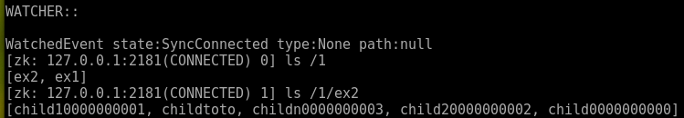

Yes, after restarting the session, we steal have our node

#### Q3

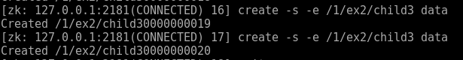

Yes it’s possible, they disappear after restart

#### Q4

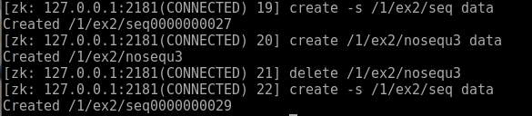

The counter is incremented at each node creation whatever the properties of node

The counter does not decrease when node delete

#### Q5

The suffix is 0000000025 (start at 0000000000)

## Scope of sequence numbers

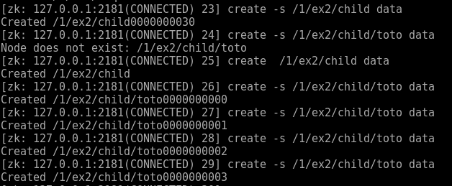

No, they are not related

## Sequence numbers across multiple clients)

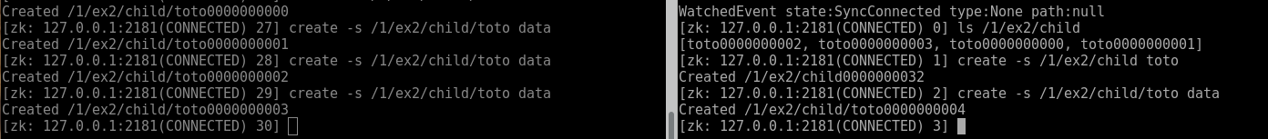

Yes are related, the counter remain across the session

# Watches

## Create the root znode for this exercise with path



## (First watch)

|  |
| --- |
|  |